What does it all actually mean?

Purpose: Nutrition is a topic that everyone thinks they have a valid opinion about. You are constantly told what you should or shouldn’t eat. Everything has a nutritional value label on the back of the package, but what does all of that information actually tell you?
Method: You will collect data on different foods that are a part of your normal diet/eating habits. You must take a picture of the nutritional value label of at least five items. You will then translate what the label says into English. Afterwards, you will compare and contrast each item to figure out which of them is the healthiest and which is the worst. Finally, you will need to write a conclusion/reflection about the data you have recorded. Was there anything surprising that you learned about the foods you eat? How has this project changed the way you plan to eat? Questions like these should be answered in your reflection.
Below I will provide a rough example of what is expected of you. This will be handed in as a scientific report.
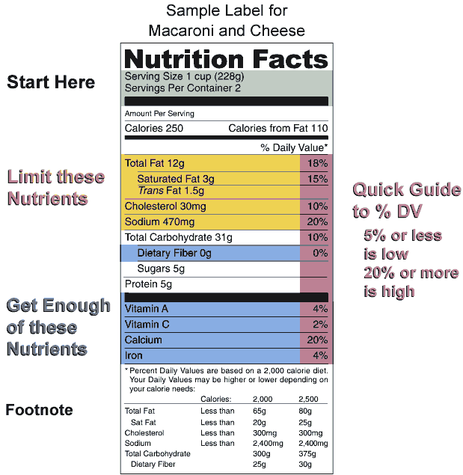

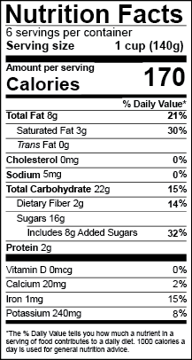
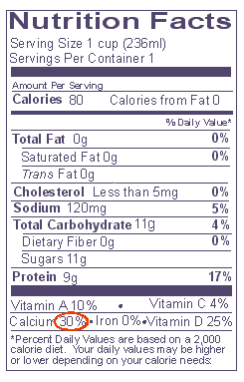

 | Mac and Cheese | 12 Grain Bread | French Fries | Pocky | 7/11 meal
Calories | 250 | 80 | 200 | 53 | 170
Saturated Fat (g) | 3 | 0 | 3 | 2 | 2
Trans Fat (g) | 1.5 | 0 | 3 | 0 | 0
Cholesterol (mg) | 30 | Less than 5 | 15 | 10 | 120
Sodium (mg) | 470 | 120 | 400 | 12 | 300
Dietary Fibers (g) | 0 | 0 | 0 | 0 | 3
Sugars (g) | 5 | 11 | 1 | 9 | 2
Protein (g) | 5 | 9 | 0 | 0 | 12

Conclusion:
After gathering my info and comparing all of the foods I eat, I was really shocked at the results. I usually eat one meal from 7/11 a week. I thought it would be much worse for me because it is a frozen, pre-packaged meal, but it doesn’t seem to be that bad. I was not really surprised by the French fires. It is common knowledge that they are an unhealthy food, but I love them. ……

