1.7 COVID-19 Build an Argument
Purpose:
This essay will facilitate you to communicate your ideas/opinions in combination with scientific evidence. You’re going to be working on your cognitive skills (such as analysis, reasoning, interpretation, decision making, critical thinking) to develop a strong perspective on a COVID-19 related matter and be able to communicate it via an essay.

Method:
In order to deliver your information structurally you should follow the following essay outline to deliver your argument in an organized manner:
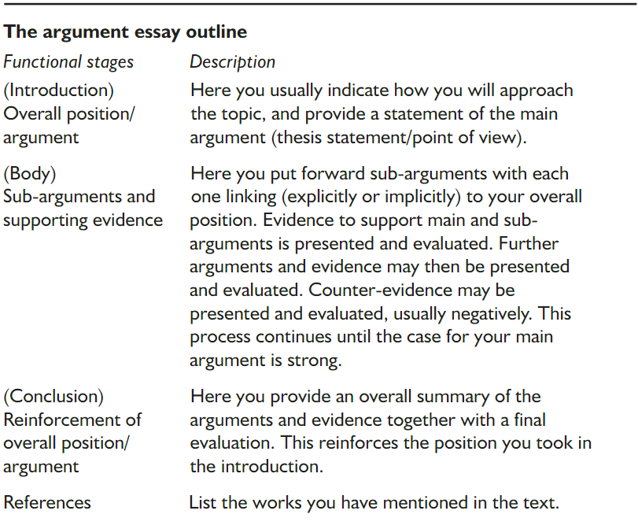
Components:
Your essay should include:
- Between 500-700 words.
- A title should be present, including your name, class, and student number.
- The essay must include a clear introduction, body, and conclusion in your essay.
- The introduction must include a statement of the main argument.
- In the body you should put forward the sub-arguments to your overall position.
- The essay must include a list of references in the end of your essay.
- The references should be from reliable sources.
- You should have at the bare minimum 6 references.

Ideas for your essay:
- Which one provides more benefits in tackling COVID-19; check-ins with QR code, or screening for temperatures upon entry.
- Which is better for battling COVID-19 in Thailand? Washing hands or anti-septic hand gels?
- Which strategies are more effective towards COVID-19? Thailand’s or Sweden’s strategies?
- Which approach is more effective against COVID-19; social distancing or wearing masks.

Additional information:
500 Word Essay Example
500 word essays greatly differ on structure, style and topics, so it may be quite difficult for a student to understand what his or her teacher expects. In such a situation, examples of essays can become a pure salvation.
500 Word Essay Format
Your 500 words essay is an example of your writing skills, talent and a thorough research, so it is necessary to know its common structure to be able to present yourself in the best light.
The first thing you need to know, apart from a 500-word essay length, is that it requires an outline. It is a skeleton of your future work, where you make a list of all the things you want to include to your paper. In such a way, you get a chance to structure your thoughts and present them in a clear manner.
Your essay should consist of such parts, as:
- Introduction, where you should introduce the reader to the topic, explaining your main ideas. Don’t forget to close this paragraph with a thesis statement, which contains a hook;
- Main paragraphs. Here you need to describe all of your thoughts and evidence, supported by facts. Don’t forget that all of the sources should be properly sited and placed along the text;
- Conclusion. In this section, you need to shape your thoughts into a clear statement, summing every part of your work. Don’t forget to paraphrase your thesis statement and make prognosis for the future. A great idea will be to encourage the reader to dive deeper into the subject and learn more about the topic from various sources.
How Long is 500 Words Essay
Many students wonder how long is a 500-word essay, what paragraphs it should consist of and what fonts they need to use. Luckily, this assignment is perfect for those, who want to add some individuality to an accepted structure, as you can tailor your work to the common demands.
First, any word processor is able to calculate the number of words for you, so you don’t have to do it manually. For example, if you are using MS Word, the word count is visible in the bottom of the screen, in the left corner. In such a way, you can be sure that you don’t exceed the required amount of words.
If you decide to use double spaces and a font of 12 pt size, your essay will be around a page and a half long. If you want to reduce it to a single page, you should use single spaces. Try to stick to the widely accepted fonts, like Times New Roman or Arial. In such a way, your audience will concentrate on the plot and not on the visual side of your work.
Once you have chosen a topic for your 500-word paper, you can select the type of your future work. It may be a definition essay, a persuasive or a descriptive one. They all differ depending on the goal you are chasing: to define a term, to persuade the reader or to describe an event or matter from your own life.
Just make sure you select an interesting topic and have enough time in advance to polish your essay! If you have any questions left, don’t hesitate to contact the teacher and he will gladly help you to improve your academic performance.

