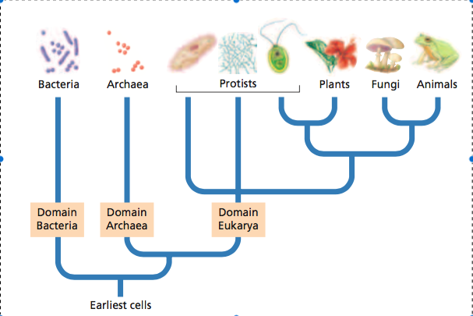

Bacteria- A group of unicellular microorganisms that have cell walls, but lack organelles and an organized nucleus, including some that can cause disease.
Archaea- similar to bacteria in size and simplicity of structure, but different in molecular organization. Looked at as an ancient intermediate between bacteria and eukaryotes.
Protists- any numerous eukaryotic organisms that are not fungi, plants, or animals and are mostly unicellular or colonial. Protists that are multicellular do not have cells that differentiate into tissues. Protists include the protozoans, certain algae, oomycetes, and slime molds.
Fungi- any of a group of unicellular, multicellular, or syncytial spore-producing organisms feeding on organic matter, including molds, yeast, mushrooms, and toadstools

Domains- There are three domains pictured: Eukarya, Bacteria, and Archaea. These are the subdivisions for all organisms.
Kingdoms- We can observe six different kingdoms with four of them belonging to the Eukarya Domain: Protista, Plant, Animal, and Fungi. Bacteria and Archaea make up the last two Kingdoms.

